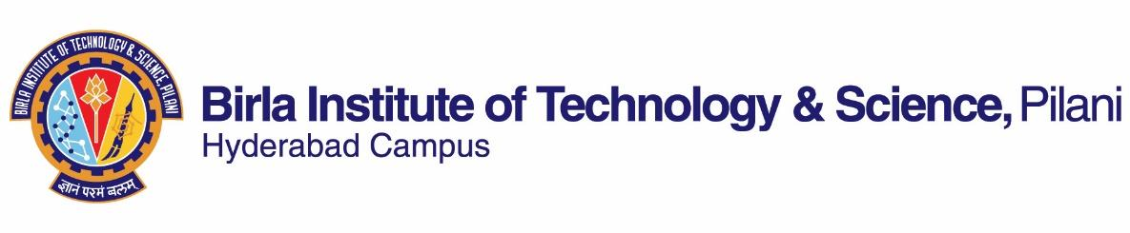

**SECOND SEMESTER 2018-2019**

# Course Handout Part II

Date: 07-01-2019

1. **Course Number: HSS F266**
2. **Course Title: Study Project**
3. **Instructor IC: Biswanath Dash**

Room No. C 212, Department of Humanities and Social Sciences,

BITS Pilani, Hyderabad Campus

1. **COURSE DESCRIPTION**

The project type course is aimed at developing the ability of the student to explore specific humanities and social science research problem and in the process learn from it. Each of these project requires, student to search for relevant literature, develop a broad understanding of the issues involved and build their skills in summarizing learnings in the form of mid-term and final report and seminar presentation. The course overall requires significant amount of reading and reflecting on the respective topic.

1. **Evaluation Scheme:**

|  |  |  |  |
| --- | --- | --- | --- |
| **EC No.** | **Evaluation Component (EC)** | **Weightage** | **Due Date** |
|  | Project Outline & Plan of Work Seminar I/ Viva I  Mid Sem. Report  Mid Sem. Seminar | 10  10  10  15 | 15.02.2019  14.03. 2019  21.03. 2019  21.03. 2019 |
|  | Final Report  Final Seminar and Viva  Weekly Interaction and Diary | 25  20  10 | 23.04. 2019  23.04. 2019  ---- |

**6. Notices:** Notices, if any, will be displayed on CMS.

7. **Project Report**: The project report shall be submitted to your Instructor. The reports will be checked by the instructor using **Turnitin** software. **A soft copy of the midsem and final report is to be submitted to the Instructor in-charge**.

8 **Academic Honesty and Integrity Policy**: Academic honesty and integrity are to be maintained by all the students throughout the semester and no type of academic dishonesty is acceptable.

**Biswanath Dash**

**INSTRUCTOR-IN-CHARGE**